Introduction to Langchain:

Model.ts
Added Model.ts file under src folder and added the implementation
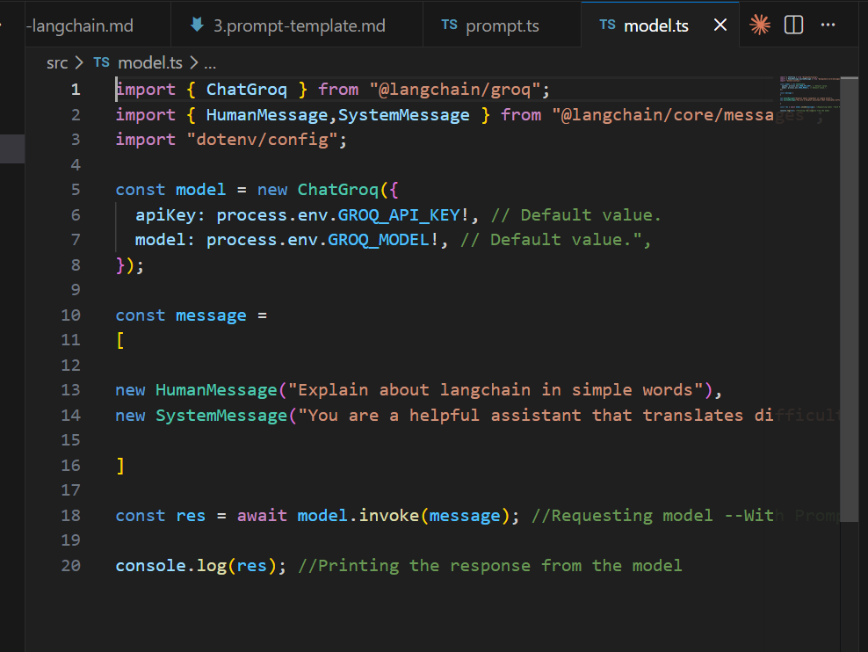

Updated Groq APIKey and Model in the env file:

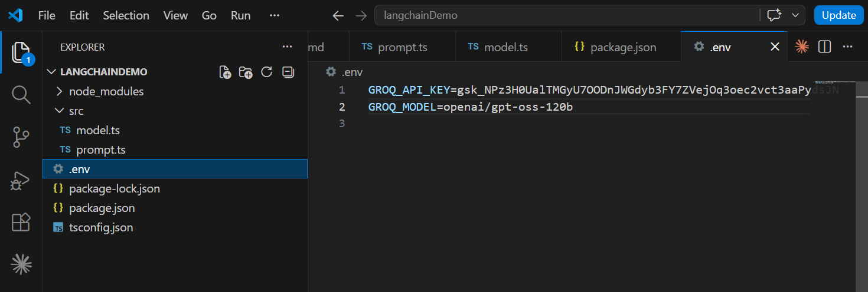

Updated package.json and tsconfig.json:
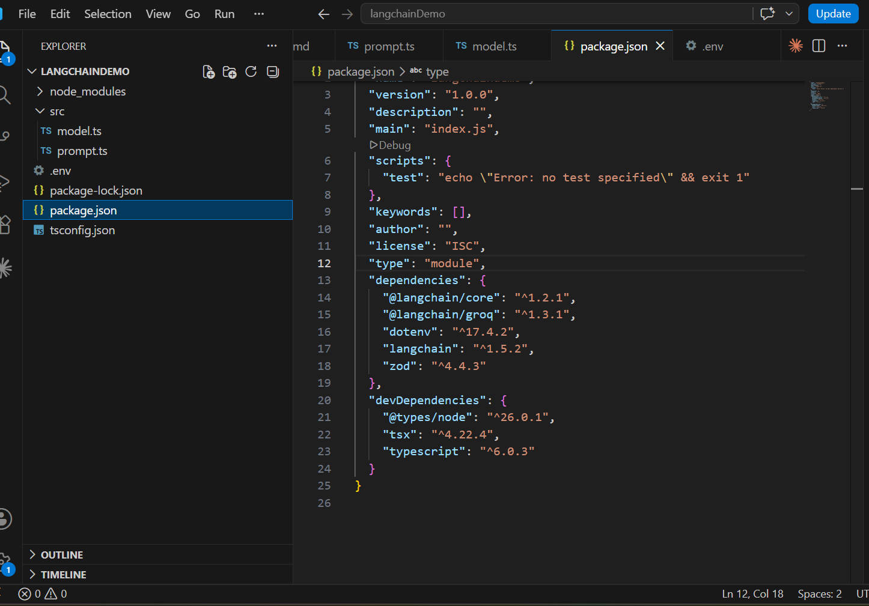

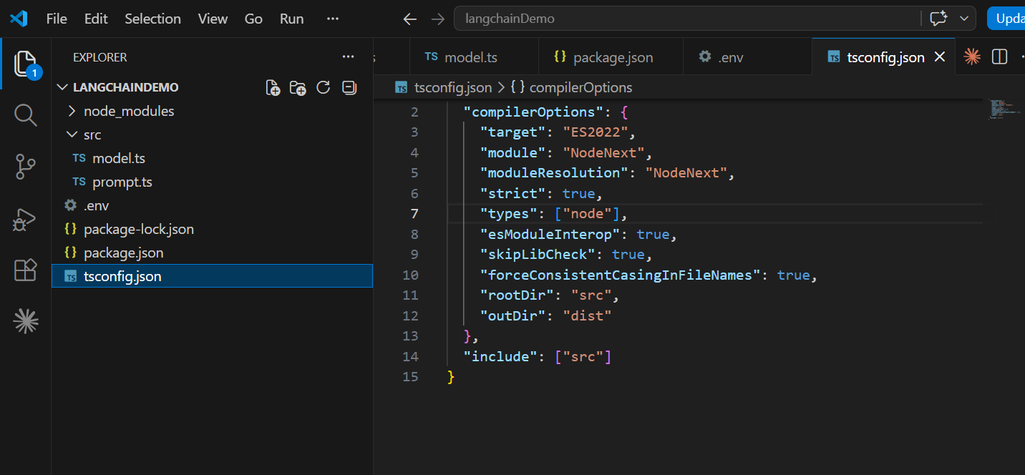

Running the model.ts file in the terminal:
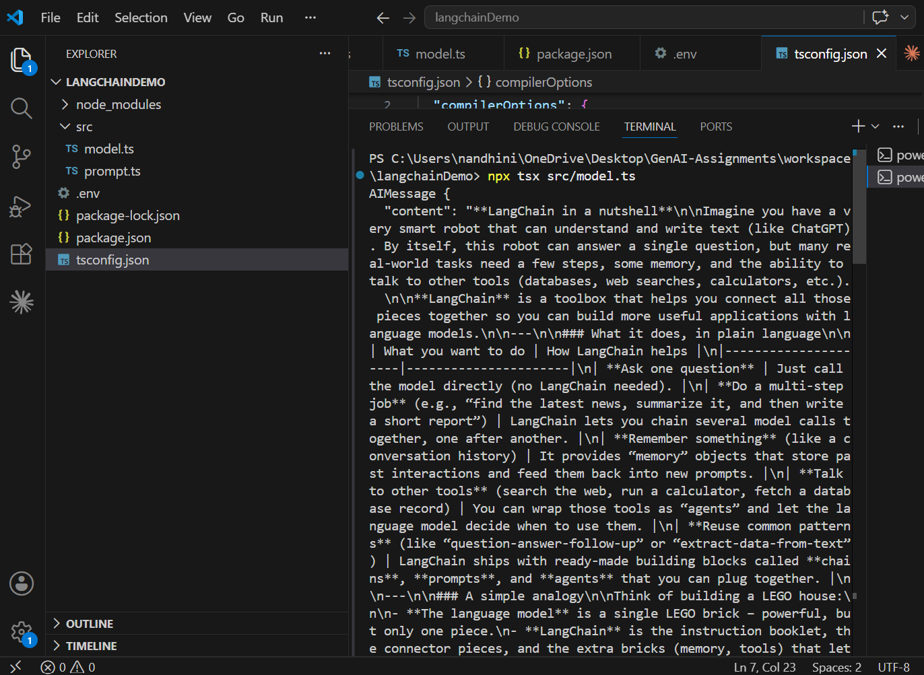

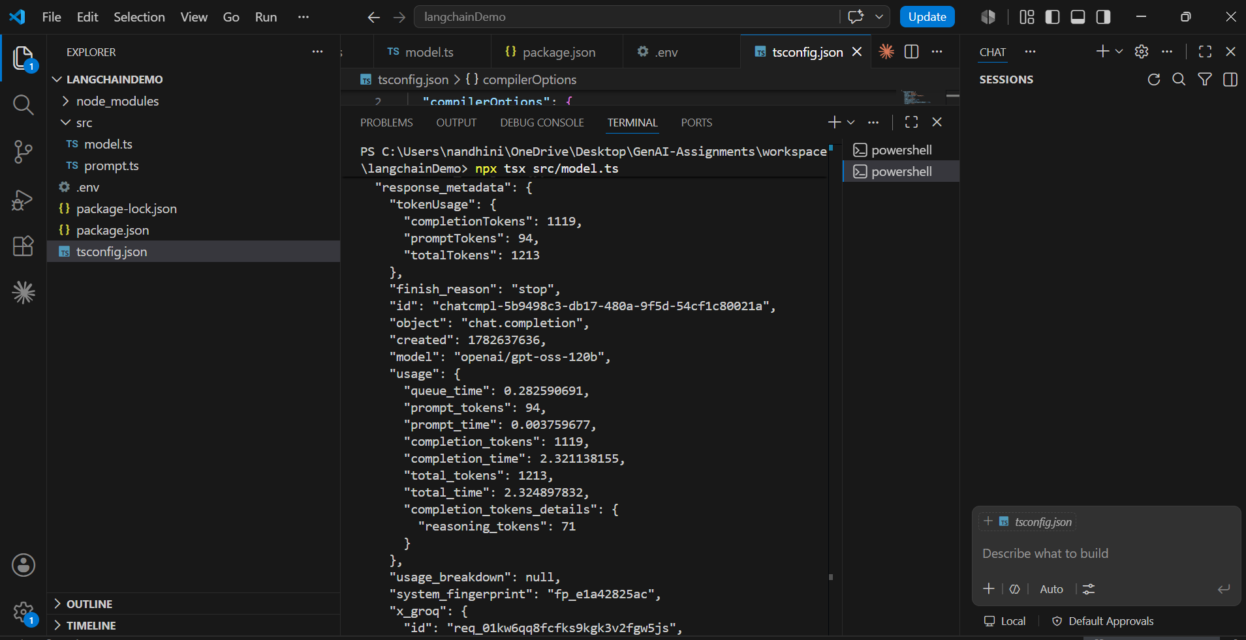

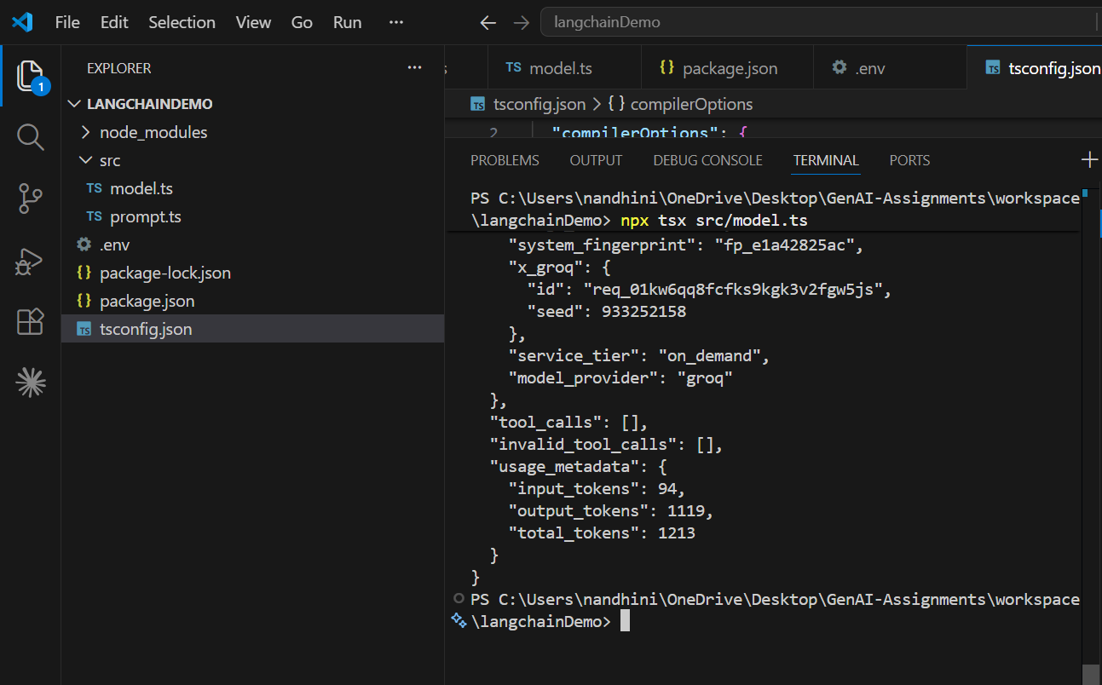

Prompt.ts:

Added prompt.ts file and updated the code:
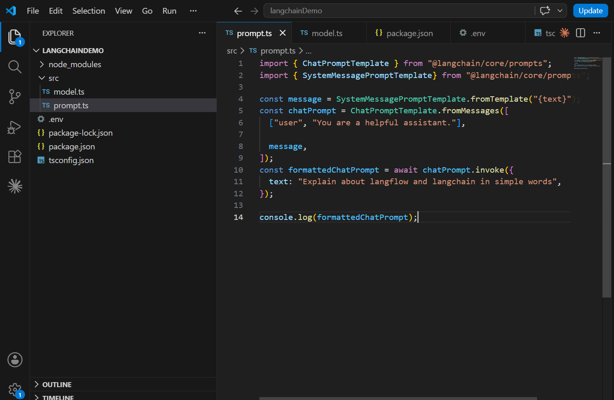

Executed npx tsx src/prompt.ts command in the terminal and got the response successfully:
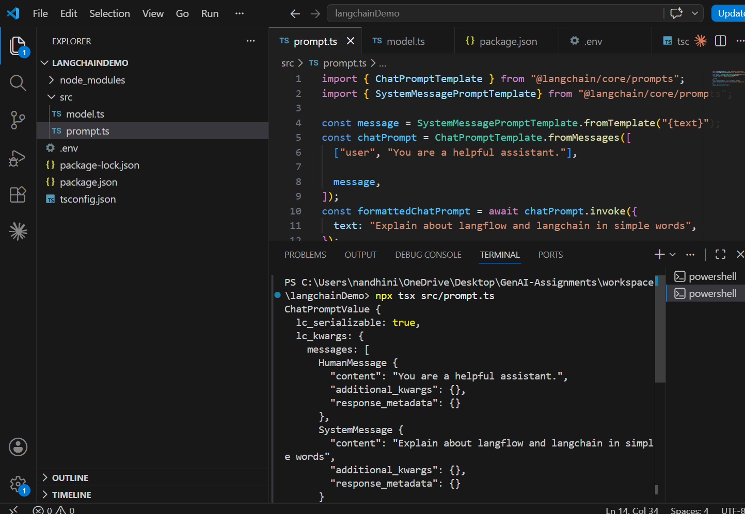

Chains.ts
Added chains.ts file and updated the code:
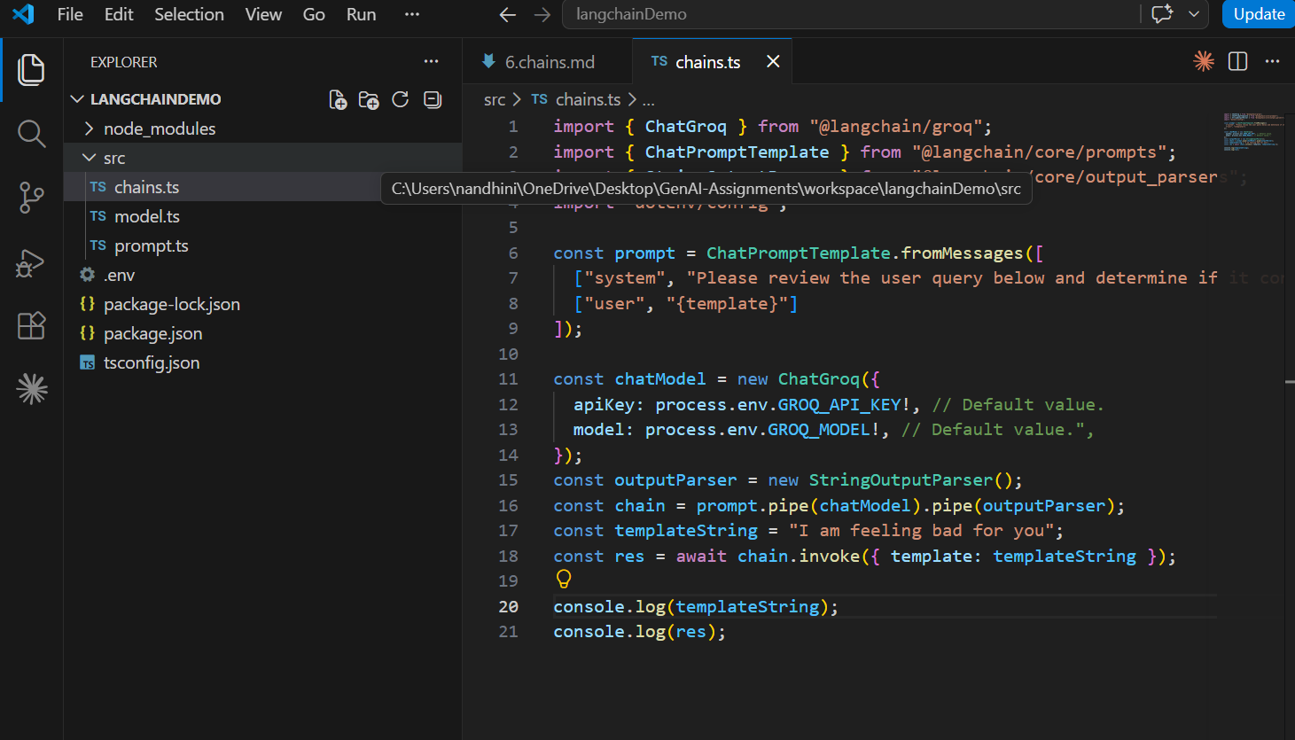

Executing the chains.ts file, printing both templateString given and the LLM result on analysis:
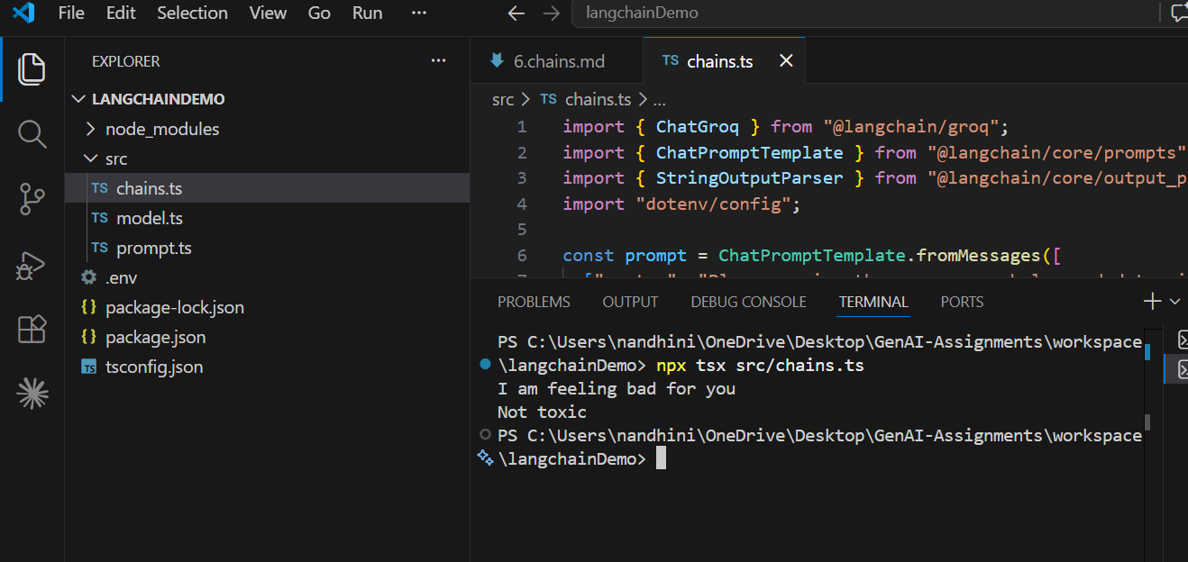

toolIntegration.ts

Added toolIntegration.ts file with the code
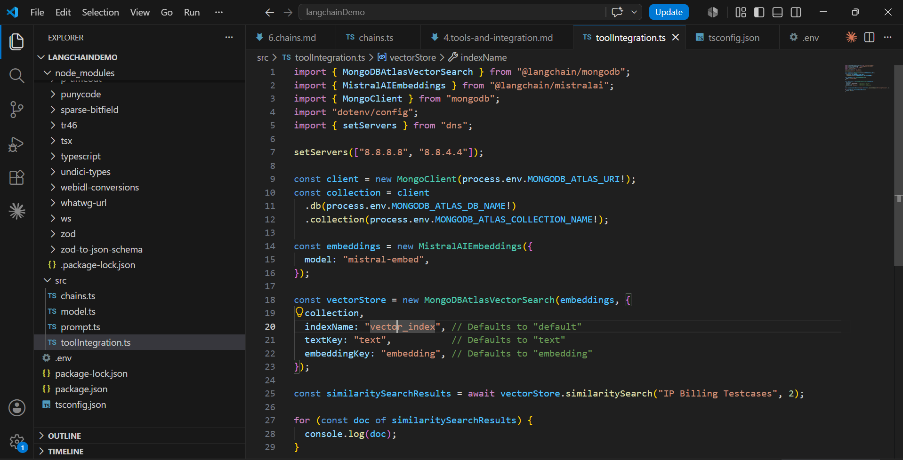

File is not executing due to loop issue, Informed Prabhakaran and Sudharshan, will try again when the issue is resolved:
